**https://www.gotomeet.me/Venu-Gopal-A**

As part of this course we are going to cover

* + ASP.NET MVC 5.0
  + Entity Framework 6.0
  + Web API 2.0
  + Angular 2 and Angular 4,5
  + Html & jQuery 🡪 Some Extend Only

Prerequisite:

Basic knowledge of .Net Framework 3.5/4.5, C#, Visual Studio is required.

It’s good to have a idea about the below topics

*C#:*

* + - * *Reflections*
      * *LINQ*
      * *Lambda Expressions*
      * *Dynamic, Task, Async, Await*
      * *Extension Methods*

ASP.NET Web Forms:

* Session
* Caching
* Master Pages
* User Controls
* Global.asax
* HTTP Handlers
* Configuration Files
* Authentication & Authorisation
* SSO & OAuth
* Our Base Framework is .Net
* From .Net Asp.Net is created.
* Asp.Net is a framework for creating web applications.

ASP.NET

Web Forms MVC

M Model

V View

C Controller

What are Model, view and Controller?

If we speak at a low level, everything is a class. I.e. Model is a class, view is a class and controller is also a class.

**Model**: Model represents shape of the data and business logic. It maintains the data of the application. Model objects retrieve and store model state in a database.

***Model is a data and business logic.***

**View**: View is a user interface. View display data using model to the user and also enables users to modify the data.

***View is a User Interface.***

**Controller**: Controller handles the user request. Typically, user interact with View, which in-tern raises appropriate URL request, this request will be handled by a controller. The controller renders the appropriate view with the model data as a response.

***Controller is a request handler.***

When the user enters a URL in the browser, it goes to the server and calls appropriate controller. Then, the Controller uses the appropriate View and Model and creates the response and sends it back to the user.

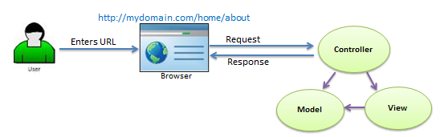



Points to Remember:

* MVC stands for Model, View and Controller.
* Model is responsible for maintaining application data and business logic.
* View is a user interface of the application, which displays the data.
* Controller handles user's requests and renders appropriate View with Model data.

# ASP.NET MVC Version History:

MVC Version VS .Net Version Release Date

1.0 2008 .Net 3.5 2009

2.0 2009 .Net 3.5/4.0 2010

3.0 2010 .Net 4.0 2011

4.0 2010 SP1, .Net 4.0/4.5 2012

2012

5.0 2013 .Net 4.5 2013

5.2-Current 2013 .Net 4.5 2014

If we observe the latest URL’s of any sites we didn’t find page which is existing with the extensions like .aspx or .php etc. These are developed by using latest technologies.

<https://www.olx.in/vehicles/categories/>

<https://www.olx.in> --🡪 Domain Name

vehicles/categories --🡪 Segments

Request Life Cycle of MVC

